October 2025 – A very busy Fall on Holley Mountain Airpark
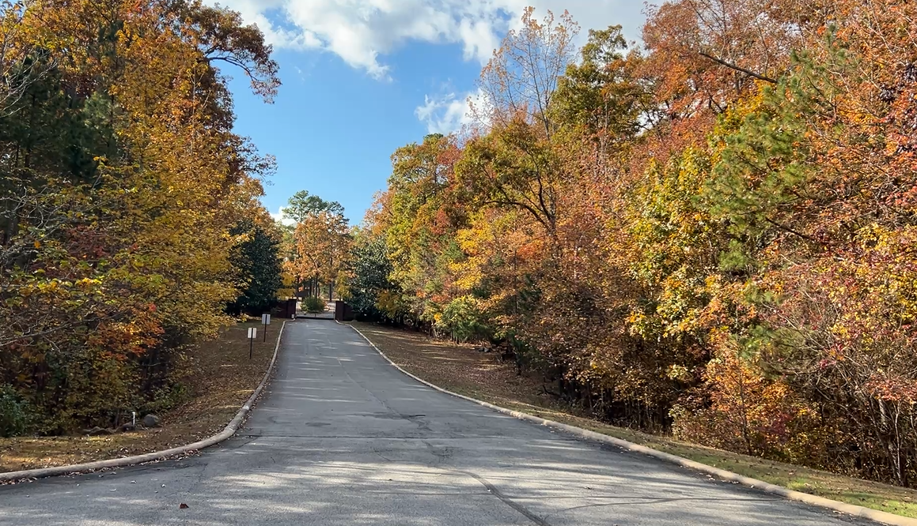

Oct. 3rd - One of the many advantages of living in an Airpark community, we can take advantage of fantastic weather here in Clinton, AR. We had an impromptu Fly-out lunch at Gastons Resort on the White River in Lakeview, AR. There is a 3200ft grass runway a short walk from the river and restaurant.

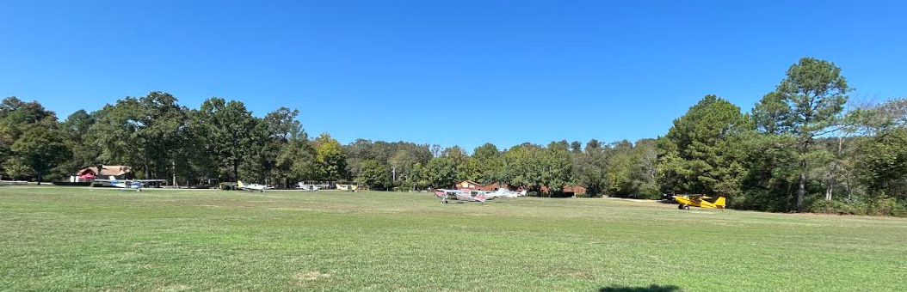

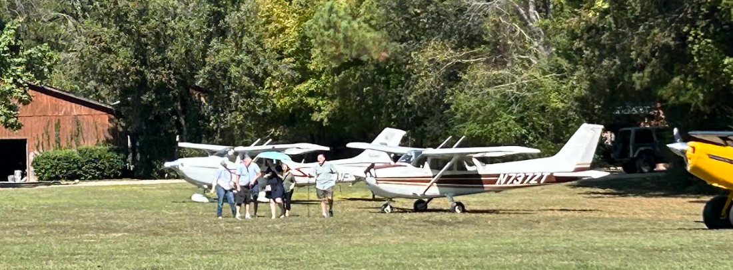
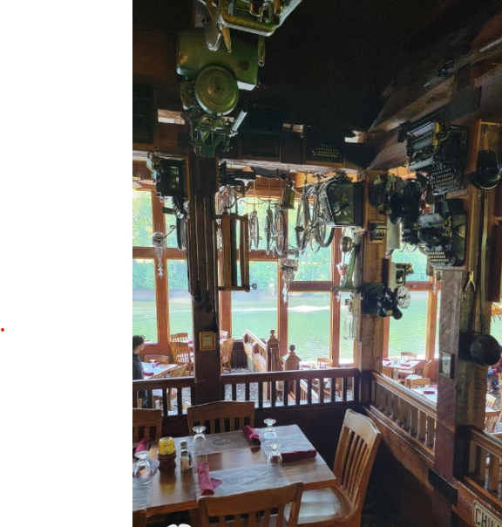
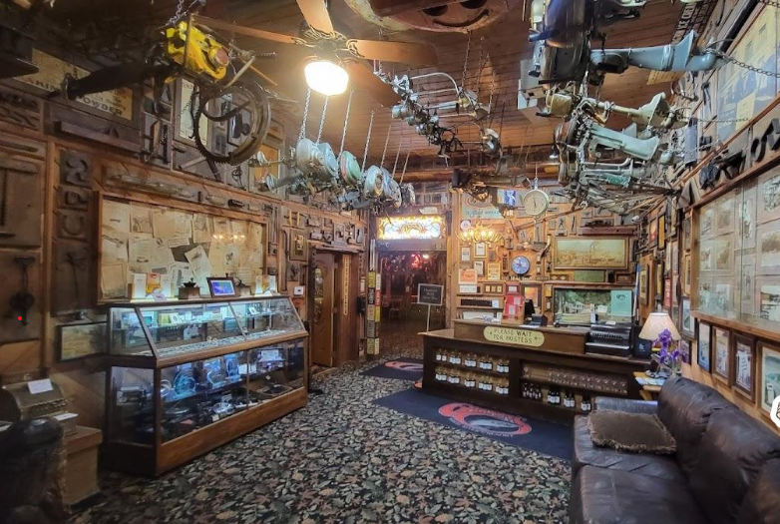

October 5-10 – Again this year, several HMA families went camping at Petit Jean Start Park in Morrilton, AR. We LOVE this campground. We took several bike rides to the many look-out sites within the park. We packed a picnic lunch and enjoyed perfect fall weather again this year. We also spent one morning playing Disc Golf at the local college and had lunch at a diner just down the road.
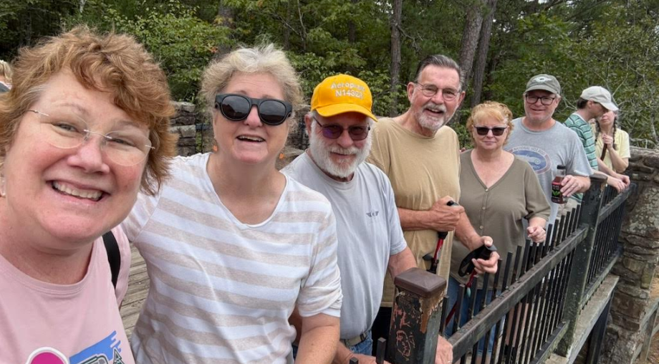

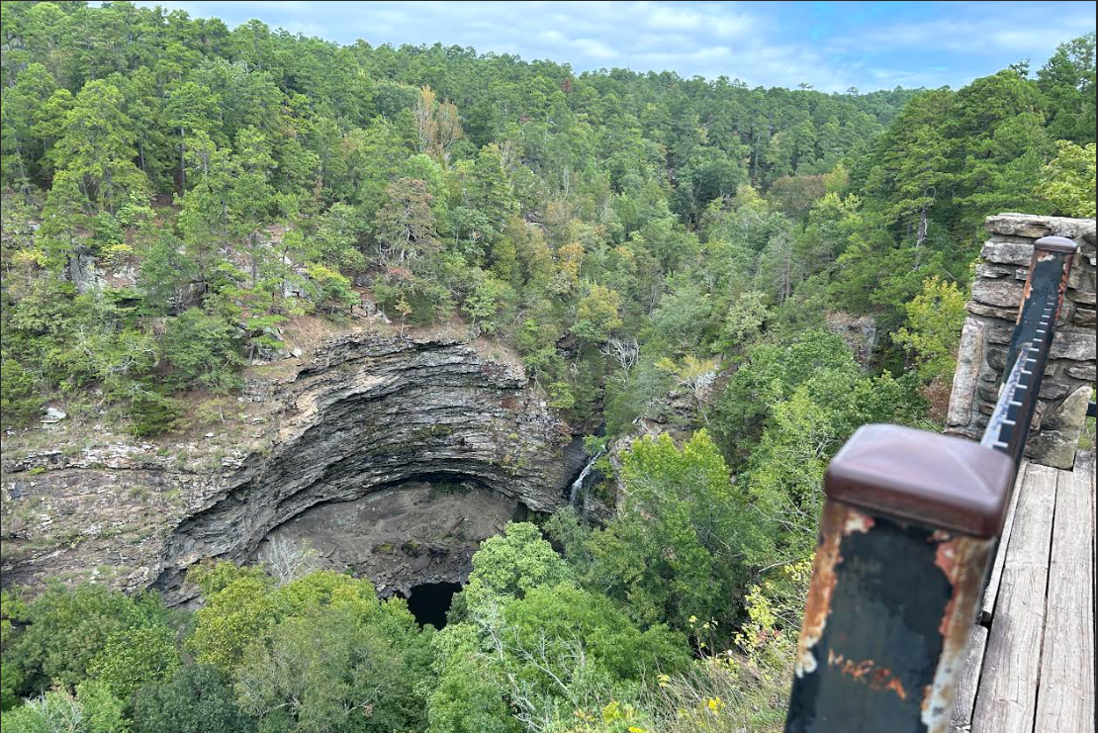

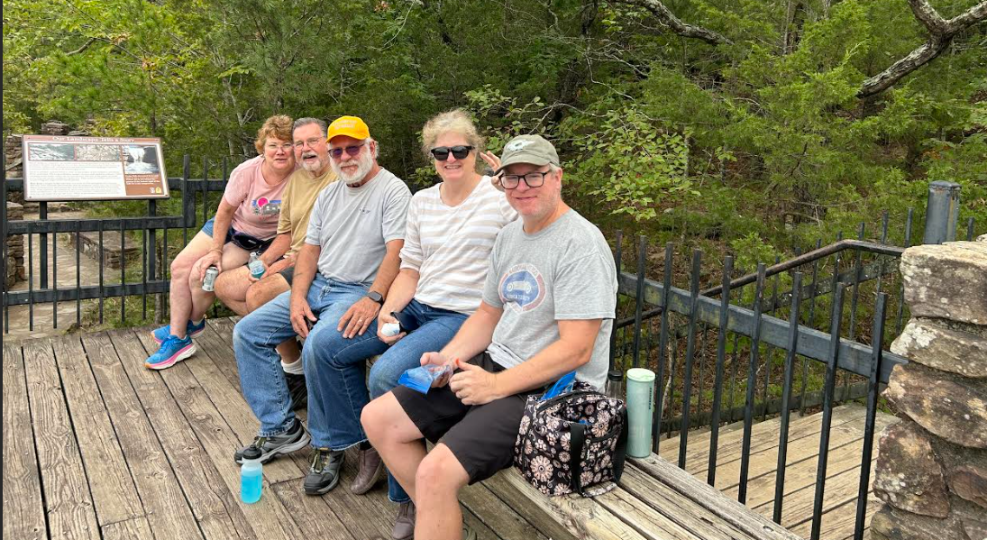

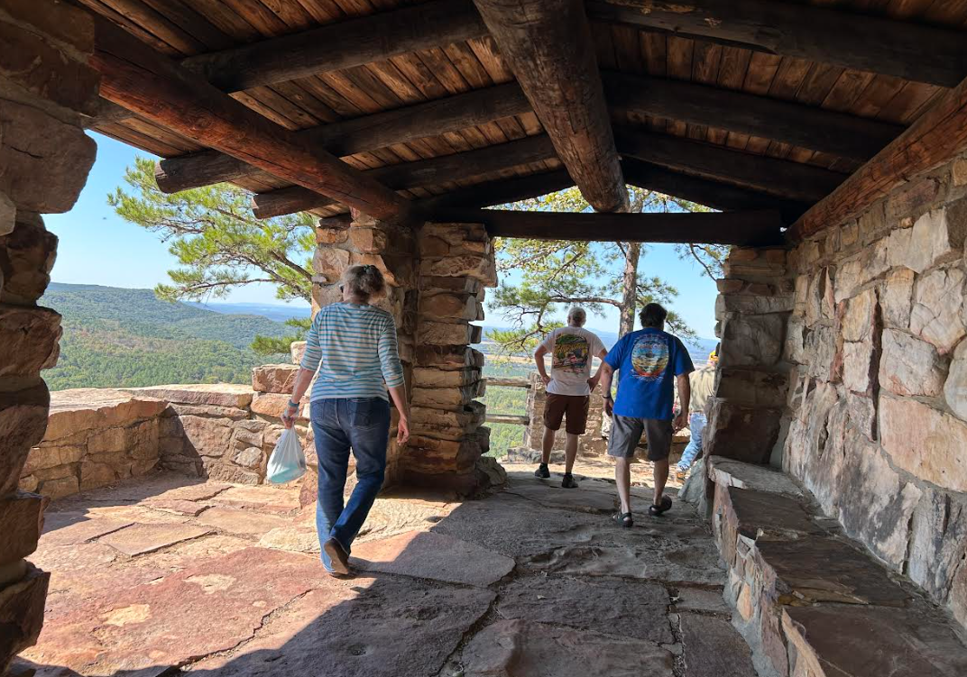
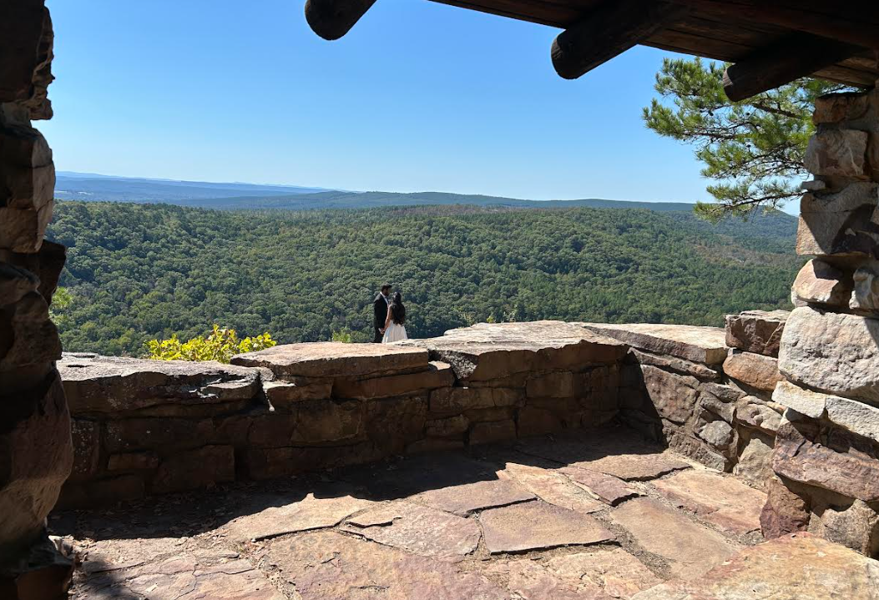
Evenings at Petit Jean Campgrounds are perfect hanging out around a camp fire.
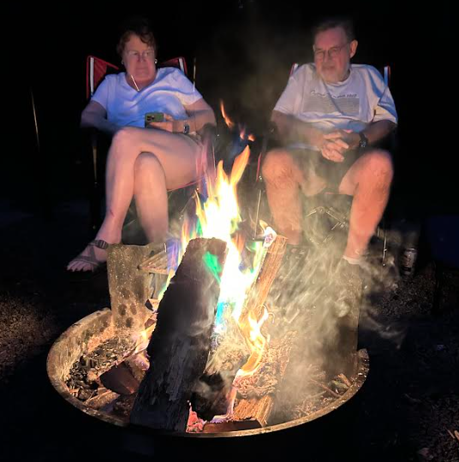
While at Petit Jean, the Petit Jean Airport (across the lake from the campgrounds) had a Fly-in with many Powered Parachutes. Many of us brought our lawn chairs and watched the night flying.
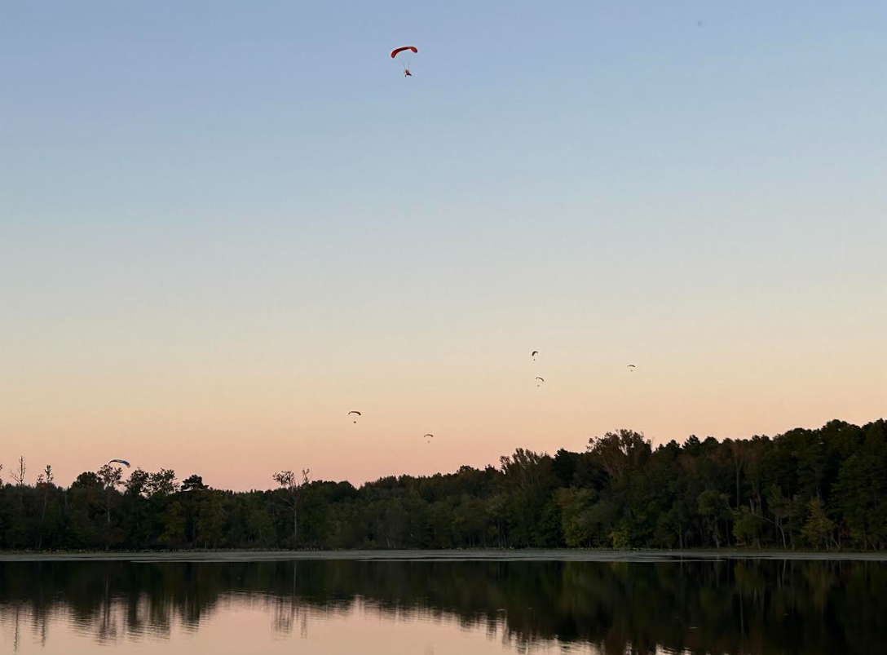
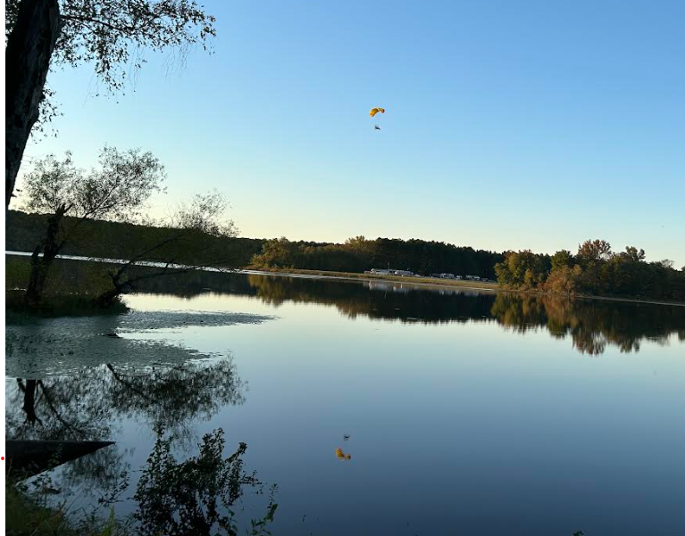

Oct. 25th – The Beers hosted a 1980 “Murder at the Dance Club” murder mystery party. Twenty HMA residents attended, it was so much fun!
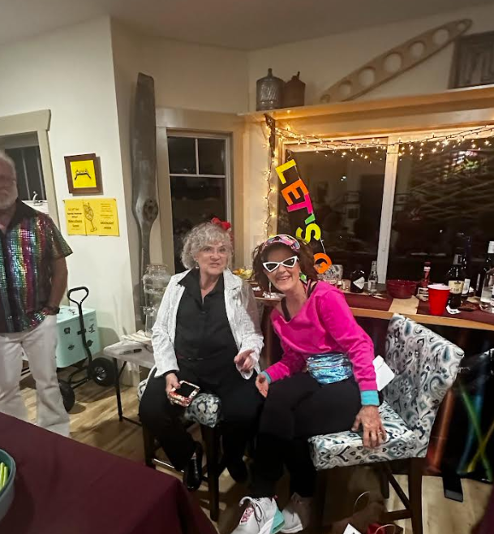
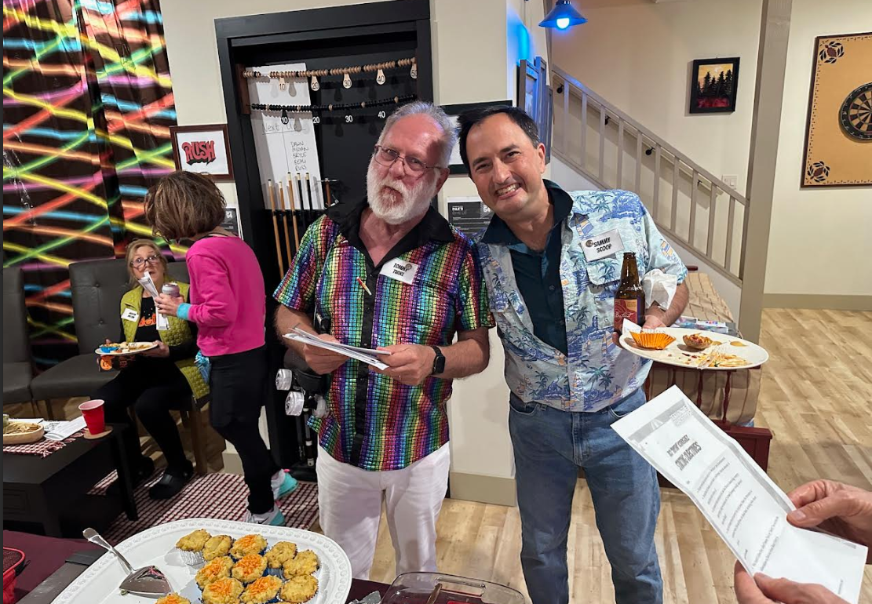
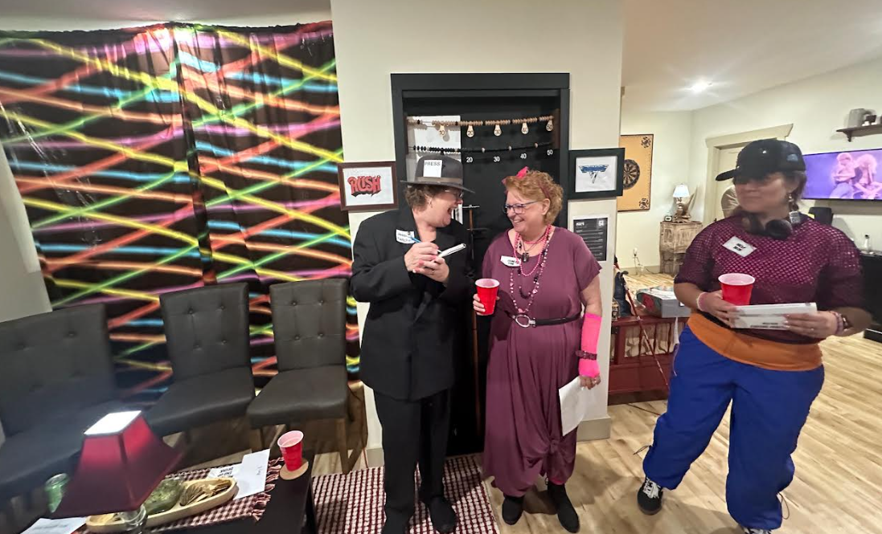
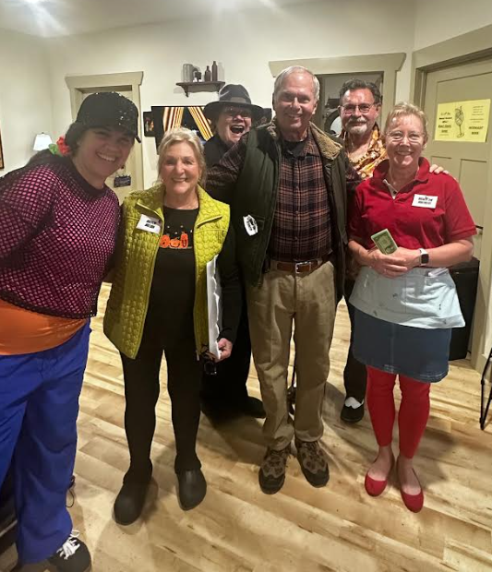
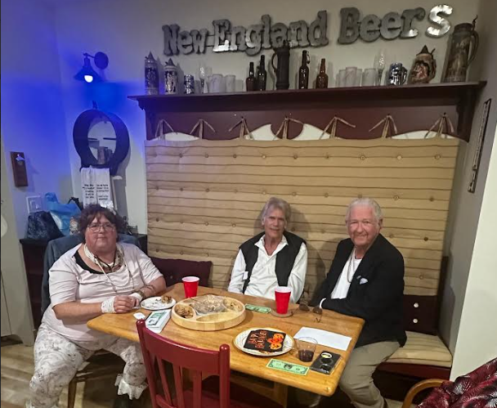
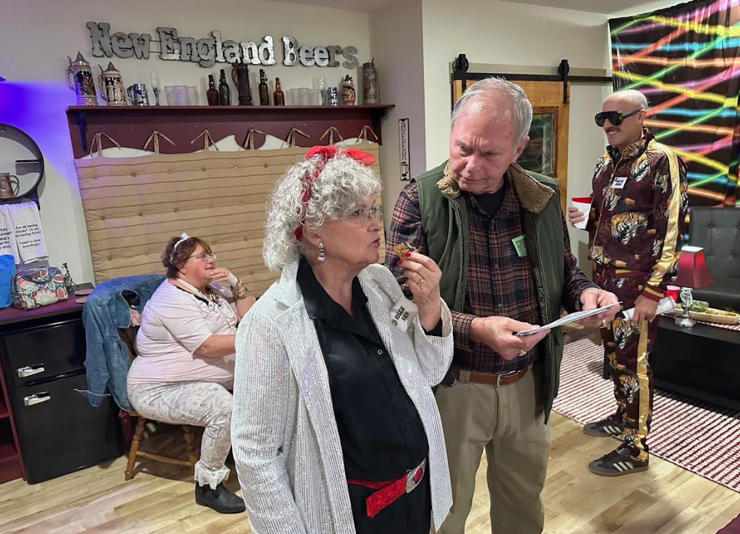
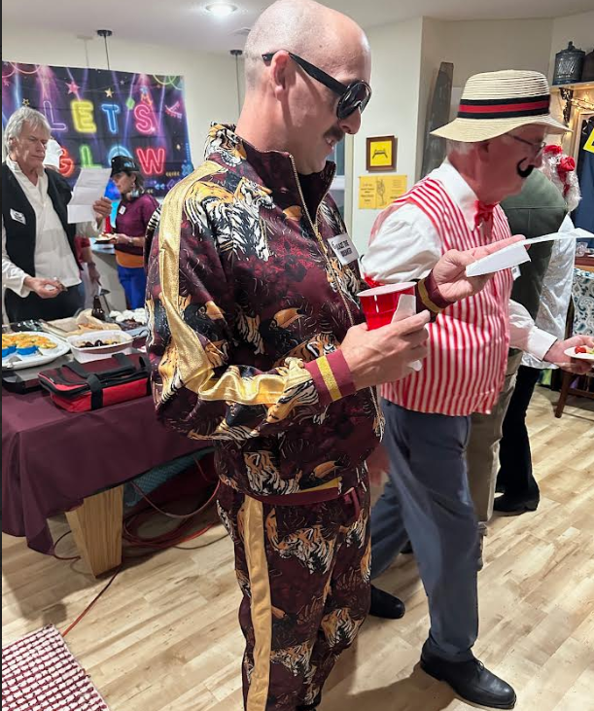
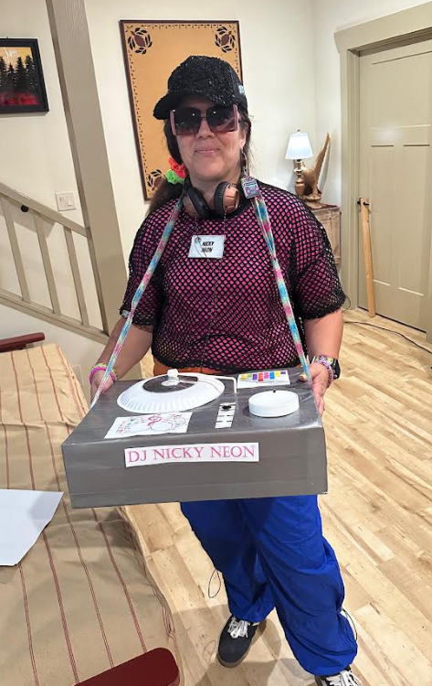
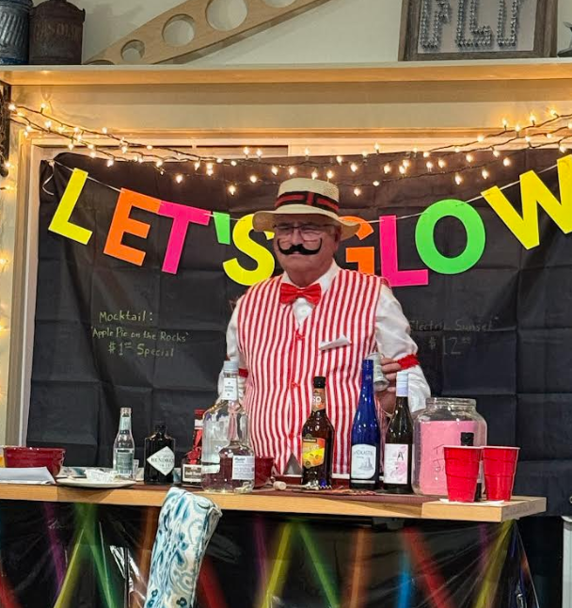



Oct. 31st – We celebrated Halloween with popcorn and a viewing of “Young Frankenstein” in the HMA community room. Such a classic truly funny movie!

